How to sign-up for meets

Sign in to our website – www.owensboromarlins.com

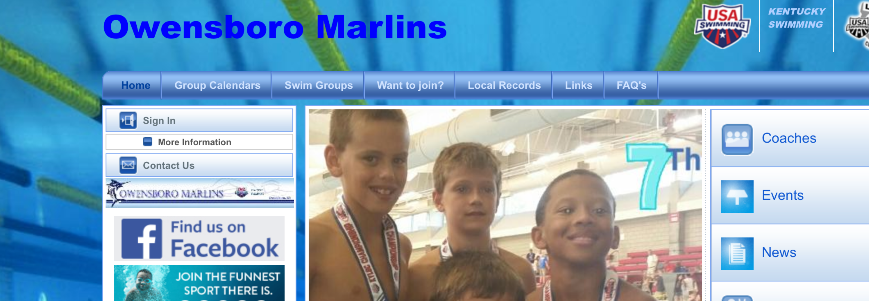

To see upcoming events scroll down until you see this section.

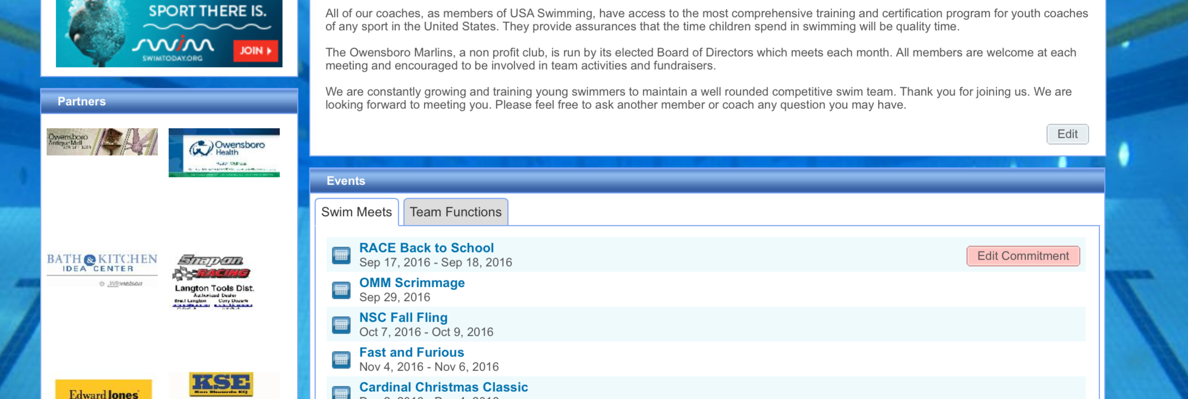

Click here to declare participation for the meet. (See next picture)
Click on the name of an event to find event information such as addresses, start times, and events in each session

Declaring Participation

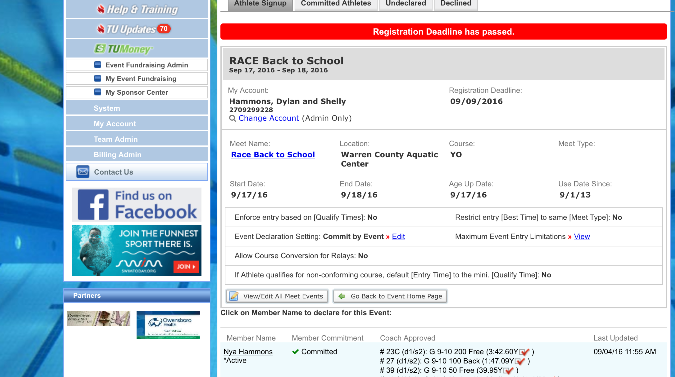

Declare participation by choosing yes or no in the drop down menu. If you have specific notes, add them in the notes section. (Such as, we will only swim on Saturday or my child does not want to swim in the 100IM.)

Look for your child’s name and click it.

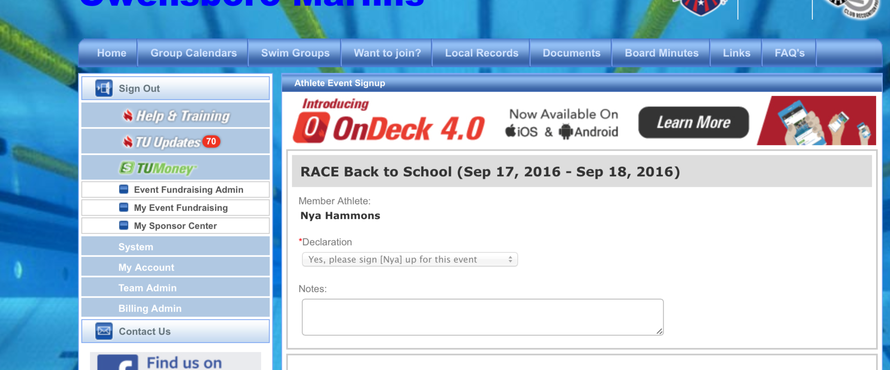

***SAVE CHANGES***

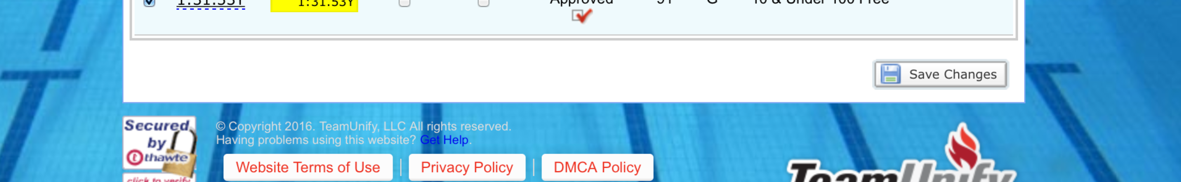
You are now signed up for the meet. Coaches will choose events for each swimmer. You can log in on a later date to see what the coach chose.

